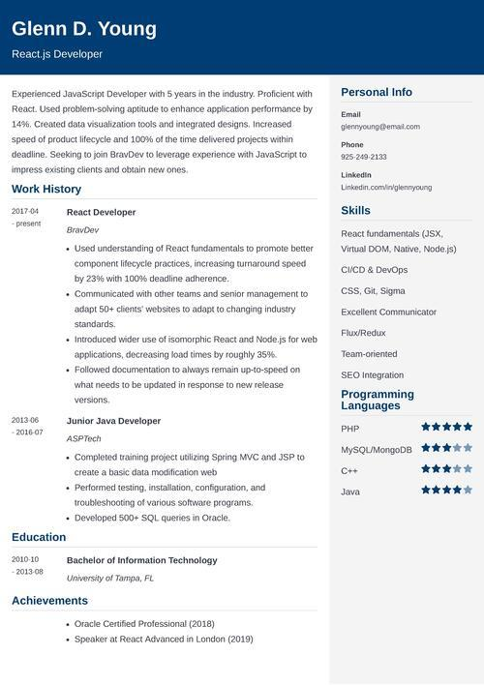
Glenn D. Young
React.js Developer
Experienced JavaScript Developer with 5 years in the industry. Proficient with React. Used problem-solving aptitude to enhance application performance by 14%. Created data visualization tools and integrated designs. Increased speed of product lifecycle and 100% of the time delivered projects within deadline. Seeking to join BravDev to leverage experience with JavaScript to impress existing clients and obtain new ones.
Work History
2017-04 -present
2013-06
-2016-07
Education
2010-10
- 2013-08
React Developer
BravDev
• Used understanding of React fundamentals to promote better component lifecycle practices, increasing turnaround speed by 23% with 100% deadline adherence.
• Communicated with other teams and senior management to adapt 50+ clients' websites to adapt to changing industry standards.
• Introduced wider use of isomorphic React and Node.js for web applications, decreasing load times by roughly 35%.
.
• Followed documentation to always remain up-to-speed on
what needs to be updated in response to new release versions.
Junior Java Developer
ASPTech
• Completed training project utilizing Spring MVC and JSP to
create a basic data modification web
• Performed testing, installation, configuration, and
troubleshooting of various software programs.
• Developed 500+ SQL queries in Oracle.
Bachelor of Information Technology
University of Tampa, FL
Achievements
• Oracle Certified Professional (2018)
• Speaker at React Advanced in London (2019)
Personal Info
Email
glennyoung@email.com
Phone
925-249-2133
Linkedin
Linkedin.com/in/glennyoung
Skills
React fundamentals (JSX, Virtual DOM, Native, Node.js) CI/CD & DevOps
CSS, Git, Sigma
Excellent Communicator
Flux/Redux
Team-oriented
SEO Integration
Programming Languages
PHP
MySQL/MongoDB
C++
Java

